Phosphates and Acid Rain in our Water
Overview: Students will test the impact of fertilizer and acid rain on pond water.

Purpose:
1. Discuss how plants take up fertilizer from the soil along with water by capillary action to help them grow.
2. Explain that most fertilizer applied to the plant is not used and washed away in runoff from rain.
3. Challenge and inspire them to run a scientific experiment following the scientific method.
4. Use the experiment to show what happens when too many nitrates and phosphates enter our lakes and ponds.
5. Explain the purpose and goals of CASFER … the nitrogen circular economy.

Materials:
1. 4 glass jars
- Purchase jars at Walmart: bit.ly/47hUDnf
2. Put some pond water in each glass jar, preferably with algae already beginning to grow, but any stagnant water will work.
3. Buy Bone Meal fertilizer with added nitrates and phosphates.
- Purchase Bone Meal fertilizer at Walmart: bit.ly/4cYQLsn
4. Put a little distilled Vinegar in each jar to simulate acid rain
- Purchase vinegar from Walmart: bit.ly/3TNW739
5. Optional: you can use phosphate containing dishwasher or laundry detergent, or TSP (trisodium phosphate) cleaner that contains phosphate.

Prior to Lesson Day:
Collect pond water in each of the glass jars. Go to pond near the school if you can to give your talk extra impact (the pond you walk by every day!)
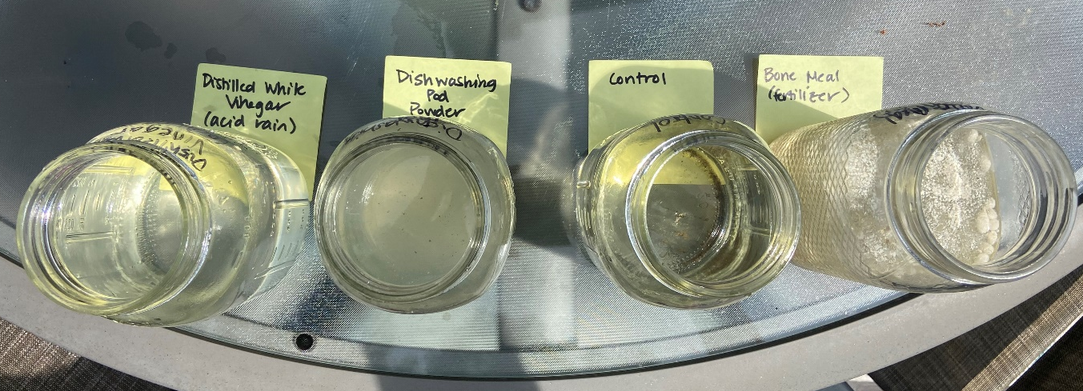
Essential Question:
How do fertilizers (especially phosphates) and other pollutants impact our environment?

Introduction:
Explain that algae is a normal part of a pond’s ecosystem. However, certain pollutants can change the growth rate of algae making it grow faster, or even not at all. Phosphate is one of the most important nutrients for plant growth, and therefore included in fertilizers. However, it can cause algae and other aquatic plants to grow too fast. When there is too much algae, it can consume too much oxygen in the water making it hard for other life in the pond, like fish and frogs, to breathe.
Another pollutant that can harm the ecosystem of ponds is acid rain. If the pH of the pond becomes too acidic, algae and other living things can be killed. We need a balance of just the right amount and type of algae.
You will be doing an experiment with (i) pond water, (ii) pond water mixed with fertilizer, and (iii)pond water mixed with distilled white vinegar simulating acid rain. Which do you think will grow algae? Which will grow algae the fastest? Which will not grow any algae? Any other predictions?
You can do this experiment ahead of time and bring the sealed jars with you, if you are making a presentation (better idea), or you can bring color pictures and pass them out for the students to see.
Experiment:
1. Fill 3 jars with pond water, preferably with algae to help the process move along faster. You can fill additional jars (picture above) to test other phosphate compounds.
2. Label each of the jars as “control pond water”, “fertilizer pond water”, and “acid rain pond water”. (Note: you can also include a clean water control to show that our water is clean.)
3. Add some Bone Meal fertilizer to the “fertilizer pond water” jar.
4. Add a little vinegar to the “acid rain” jar.
5. Put these open jars in a warm, sunny spot outside. Alge needs sunlight to grow. Monitor these jars for a few weeks and note how they change over time. Which ones grow algae? Which ones clear up? Does one grow algae quicker than another? Take pictures for showing the effect over time.
The jar with the bone meal should have grown algae faster than the control pond water. The acid rain jar should remain clear without any living particles in it.
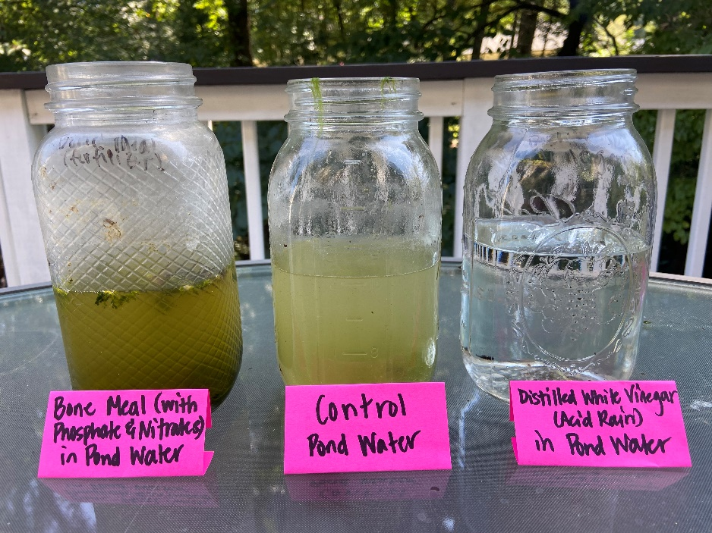
Discussion:
- Did you get the results you expected? If you did not, why didn’t you and what did you learn from your different results?
- Are there any other experiments you can do with your samples?
- Are there any other ways you can investigate what is happening in the water?
- Some scientists have been experimenting with using some algae for bio fuels. How could this work and what could we do with this?
- Swimming pools can collect phosphate from the environment, such as from leaves. You can purchase swimming pool products to lower the phosphate level in a swimming pool and prevent algae growth, like “No-Phos”.

National Science Standards that compliment this lesson:

K-2-ETS1-1. Ask questions, make observations, and gather information about a situation people want to change to define a simple problem that can be solved through the development of a new or improved object or tool.
- ETS1.A: Defining and delimiting Engineering Problems: A situation that people want to change or create can be approached as a problem to be solved through engineering; Asking questions, making observations, and gathering information are helpful in thinking about problems. Before beginning to design a solution, it is important to clearly understand the problem.
1-LS1-1. Use materials to design a solution to a human problem by mimicking how plants and/or animals use their external parts to help them survive, grow, and meet their needs
- LS1.A: Structure and Function All organisms have external parts. Different animals use their body parts in different ways to see, hear, grasp objects, protect themselves, move from place to place, and seek, find, and take in food, water and air. Plants also have different parts (roots, stems, leaves, flowers, fruits) that help them survive and grow.
- LS1.D: Information Processing: Animals have body parts that capture and convey different kinds of information needed for growth and survival. Animals respond to these inputs with behaviors that help them survive. Plants also respond to some external inputs.
2-LS2-1. Plan and conduct an investigation to determine if plants need sunlight and water to grow.
- LS2.A: Interdependent Relationships in Ecosystems: Plants depend on water and light to grow.
2-LS4.1. Make observations of plants and animals to compare the diversity of life in different habitats.
- LS4-D: Biodiversity and Humans: There are many different kinds of living things in any area, and they exist in different places on land and in water.
3-5-ETS1-1. Define a simple design problem reflecting a need or a want that includes specified criteria for success and constraints on materials, time, or cost.
- ETS1.A: Defining and Delimiting Engineering Problems: Possible solutions to a problem are limited by available materials and resources (constraints). The success of a designed solution is determined by considering the desired features of a solution (criteria). Different proposals for solutions can be compared on the basis of how well each one meets the specified criteria for success or how well each takes the constraints into account.
3-LS1-1. Develop models to describe that organisms have unique and diverse life cycles but all have in common birth, growth, reproduction and death.
- LS1.B: Growth and Development of Organisms: Reproduction is essential to the continued existence of every kind of organism. Plants and animals have unique and diverse life cycles.
4-LS1-1. Construct an argument that plants and animals have internal and external structures that function to support survival, growth, behavior, and reproduction.
- LS1.A: Structure and Function: Plants and animals have both internal and external structures that serve various functions in growth, survival, behavior, and reproduction.
4-ESS3-2. Generate and compare multiple solutions to reduce the impacts of natural Earth processes on humans
- ESS3.B: Natural Hazards: A variety of hazards result from natural processes (e.g., earthquakes, tsunamis, volcanic eruptions). Humans cannot eliminate the hazards but can take steps to reduce their impacts.
- ETS1.B: Designing Solutions to Engineering Problems: Testing a solution involves investigating how well it performs under a range of likely conditions.
5-ESS3-1. Obtain and combine information about ways individual communities use science ideas to protect the Earth’s resources and environment.
- ESS3.C: Human Impacts on Earth Systems: Human activities in agriculture, industry, and everyday life have had major effects on the land, vegetation, streams, ocean, air, and even outer space. But individuals and communities are doing things to help protect Earth’s resources and environments.
MS-LS1-5. Construct a scientific explanation based on evidence for how environmental and genetic factors influence the growth of organisms
- LS1.B: Growth and Development of Organisms. Genetic factors as well as local conditions affect the growth of the adult plant.
MS-LS2-1. Analyze and interpret data to provide evidence for the effects of resources availability on organisms and populations of organisms in an ecosystem.
- LS2.A: Interdependent Relationships in Ecosystems.
- Organisms, and populations of organisms, are dependent on their environmental interactions both with other living things and with nonliving factors.
- In any ecosystem, organisms and populations with similar requirements for food, water, oxygen, or other resources may compete with each other for limited resources, access to which consequently constrains their growth and reproduction.
- Growth of organisms and population increases are limited by access to resources.
MS-LS2-2. Construct an explanation that predicts patterns of interactions among living organisms across multiple ecosystems.
- LS2.A: Interdependent Relationships in Ecosystems. Similarly, predatory interactions may reduce the number of organisms or eliminate whole populations of organisms. Mutually beneficial interactions, in contrast, may become so interdependent that each organism requires the other for survival. Although the species involved in these competitive, predatory, and mutually beneficial interactions vary across ecosystems, the patterns or interactions of organisms with their environments, both living and nonliving, are shared.
MS-LS2-4. Construct an argument supported by empirical evidence that changes to physical or biological components of an ecosystem affect populations.
- LS2.C: Ecosystem Dynamics, Functioning, and Resilience. Ecosystems are dynamic in nature; their characteristics can vary over time. Disruptions to any physical or biological component of an ecosystem can lead to shifts in all its populations.
MS-ESS3-2. Analyze and interpret data on natural hazards to forecast future catastrophic events and inform the development of technologies to mitigate their effects.
- ESS3.B: Natural Hazards. Mapping the history of natural hazards in a region, combined with an understanding of related geologic forces can help forecast the locations and likelihoods of future events.
MS-ESS3-3. Apply scientific principles to design a method for monitoring and minimizing a human impact on the environment.
- ESS3.C: Human Impacts on Earth Systems.
- Human activities have significantly altered the biosphere, sometimes damaging or destroying natural habitats and causing the extinction of other species. But changes to Earth’s environments can have different impacts (negative and positive) for different living things.
- Typically, as human populations and per-capita consumption of natural resources increase, so do the negative impacts on Earth unless the activities and technologies involved are engineered otherwise.
MS-ESS3-5. Ask questions to clarify evidence of the factors that have caused the rise in global temperatures over the past century.
- ESS3.D: Global Climate Change. Human activities, such as the release of greenhouse gases from burning fossil fuels, are major factos in the current rise in Earth’s mean surface temperature (global warming). Reducing the level of climate change and reducing human vulnerability to whatever climate changes do occur depend on the understanding of climate science, engineering capabilities, and other kinds of knowledge, such as understanding of human behavior and on applying that knowledge wisely in decisions and activities.
MTS-ETS1-3. Analyze data from tests to determine similarities and differences among several design solutions to identify the best characteristics of each that can be combined into a new solution to better meet the criteria for success.
- ETS1.B: Developing Possible Solutions.
- There are systemic processes for evaluating solutions with respect ot how well they meet the criteria and constraints of a problem.
- Sometimes parts of different solutions can be combined to create a solution that is better than any of its predecessors.
- ETS1.C: Optimizing the Design Solution. Although one design may not perform the best across all tests, identifying the characteristics of the design that performed the best in each test can provide useful information for the redesign process—that is, some of those characteristics may be incorporated into the new design.

