Creating Seed Balls
Overview: Students will create an experiment to compare the effects of fertilizer on flowers. Students will create seed balls to grow flowers and measure their rates of growth.
Purpose:
- Teach students what plants eat and how they consume nutrients.
- Compare the differences with what humans need and what seeds need in their early-life meals.
- Challenge and inspire them to do a scientific experiment following the scientific method.
- Use the experiment they will do to show the benefit of nutrients in plant growth.
- Explain how most of the fertilizer applied to the plant is not used and washed away in runoff.
- Explain the negative effects on the environment of fertilizer runoff.
- Explain the purpose and goals of CASFER … the nitrogen circular economy.
Materials:
- Blended paper in water (see directions in Prior to Lesson Day section)
- Seeds
  - Purchase from nursery: bit.ly/47uavDi
- Cups to hold paper pulp, seeds, and Miracle Gro soil
  - Purchase on Amazon: amzn.to/3ZjYCgZ
- Miracle Gro soil
  - Purchase on Home Depot: thd.co/3z4MLZD
- Optional: colorful tissue paper for decoration
  - Purchase at Walmart: bit.ly/3zfCtWr
Prior to Lesson Day:
- Tear/shred/cut paper and let soak in water for a day.
- Blend paper in blender to make thick, gloppy, mushy paper pulp.
- Drain gloopy paper water and bring to school.
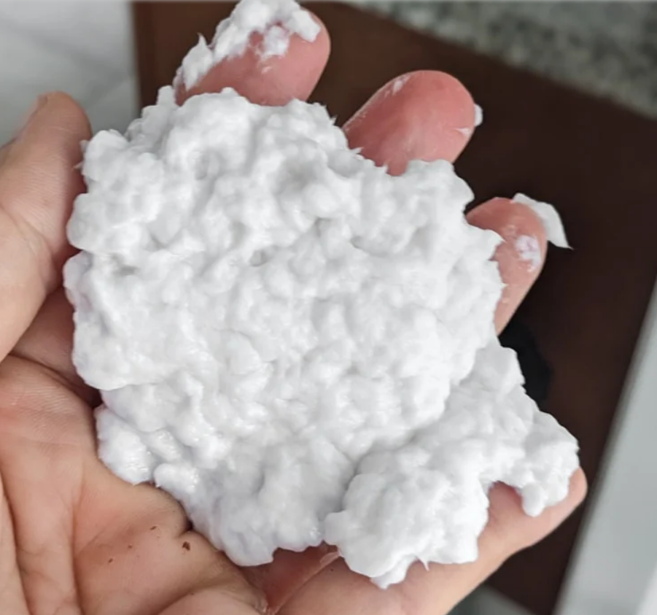
Essential Question:
How does fertilizer change seed growth?
Introduction:
Tip: Set clear expectations. Before asking students to answer, tell students to raise their hands before talking and wait to be called on.

- Ask students if they have ever been around a baby. Ask students what a baby needs to live (milk, attention, an adult to care for them, diapers, stimulation, etc.)
Note: This could turn into a “story time” lead by the kids. Be prepared with the tips below to stay on topic and within the time limits.
Tip: Set the parameters. If you see you are being inundated with students wanting to share or tell stories, let the students feel acknowledged, while still moving on. Once you have called on a few students, let them know that in the interest of time, you need to move on and only have time for one more story, but if there is time at the end, you would love to hear everyone else’s stories.

Tip: Create and incentive. If you plan on having volunteers later in the lesson, let the students know now that students who are following your directions, being respectful of each other and you, raising their hands and not calling out, etc. may be able to be volunteers and help you.

- Ask how plants and seeds are different. What does a baby plant or a seed need to grow? Where do they get their nutrients? (All of the nutrients a seed needs is contained in its shell. It just needs water and sunlight to grow.)
- After a seed begins to sprout, it needs more support. What if the soil around it does not enough nutrients for it to survive?
- Introduce fertilizer. Once seeds start growing, they need nutrients from the soil and their environment to continue growing. Scientists have learned which nutrients help plants grow and so they created fertilizer to help plants grow faster, stronger, and more heartily.
Experiment:
Each student will make at least 2 seed bombs—one with Miracle Gro soil, 1 without.
- Explain to the students that we are going to create seed balls and the kids are going to conduct their own experiments. We will create little balls of paper and seeds. We will add miracle grow, fertilizer, to half of them. Students can plant these anywhere they want after they dry, and they will watch them over the next few weeks to see which grows faster!
- At this time, ask students to make predictions about what will happen. Which will grow faster, which will grow taller, which will grow stronger.
Create seed bombs.
Recommended in groups of 3-4 students but can be done individually.
- Each group will get some paper pulp and seeds.
TIP: Talk to the teacher in advance or give the teacher your lesson plan before you begin. Ask if kids can get their own supplies or if you should have a few helpers.
Put students in groups of 3. Number students 1, 2, 3, and give each number a job.
- 1 is in charge of distributing paper pulp
- 2 is in charge of distributing seeds.
- 3 is in charge of distributing Miracle Gro soil
- 4 is in charge of clean up

.
Tip: Quickly assign roles. Tell the students that you are going to “count off” in each group.
i.Tell them that when you point them, they will say the next number so each member of the groups has a number 1-3 (or the highest number in the group).
ii. Point to the first person in the first group and say “1”. Point to the second person and say “2”, and so on. After assigning the first group, ask the class if they understand how they are counting off.
iii. Quickly point to each member of each additional group the same way, having the students take over saying their next numbers.
iv. Assign the above roles to each number. “1s are in charge of the paper pulp, 2s are in charge of the seeds. 3s are in charge of the Miracle Gro.

- Students will pour seeds into paper pulp and mix.
Tip: Set expectations and model behavior. Tell students that we are doing a science experiment, and these are materials and tools we are using, not toys or games to throw around. Just like all tools, we need to take care of them not throw them around.
Have some fun and show them brief dos and don’ts:
-Do: model keeping mixture in bowl
-Don’t: model holding mixture out of bowl and waving it around the room (BE CLEAR TO SAY DON’T)
-Don’t: model eating the mixture (BE CLEAR TO SAY DON’T)
-Don’t: model touching someone else with the mixture. (BE CLEAR TO SAY DON’T)

- Make the seed balls
Tip: Set the expectations and consequences. Explain that while everyone will get 2 seed bombs once they dry, only responsible students are allowed to make them. If students are unable to handle them correctly, they will have to watch the balls get made and won’t get to participate in the experiment.

  - Students will divide pulp/seed mixture into 2 different bowls.
  - They will make balls no larger than a golf ball with the pulp/seed mixture in one of the bowls and lay them to dry on a plate or tray to dry. Label the plate/tray as “Seeds Only”
  - Each group will get a bowl of miracle grow and mix that in with the 2nd bowl of pulp.
  - They will make balls no larger than a golf ball with the pulp/seed/Miracle Gro mixture, and lay them to dry on a plate or tray to dry. Label the plate/tray as “Seeds and Miracle Gro”
- Optional: Add some art to your seed balls.
  - Dampen pieces of colored tissue paper and wrap them around the seed balls to tell the difference between the ones with Miracle Gro and the ones without.
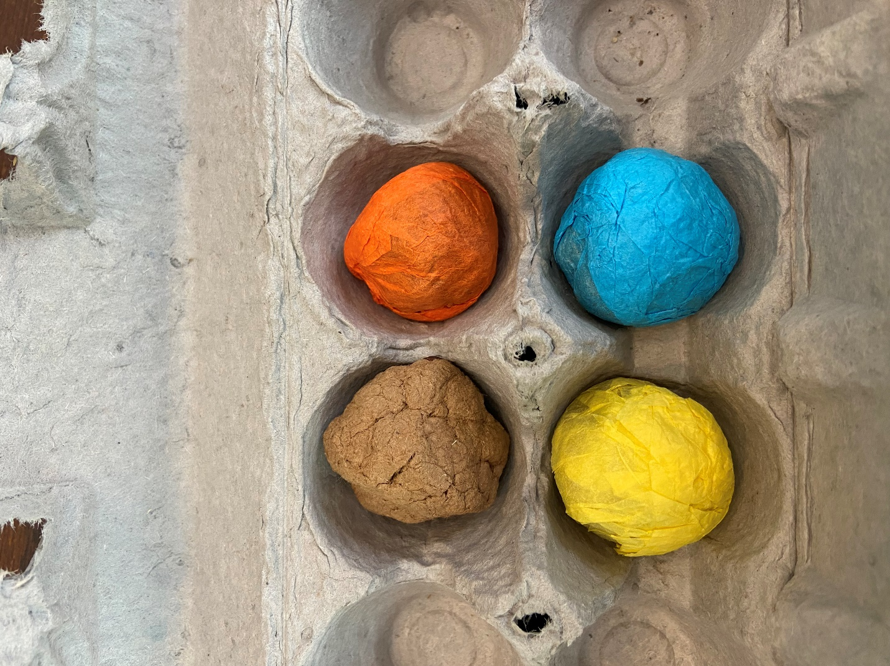
Discussion:
1. Ask students what will happen to the extra materials: paper will decompose, seeds will grow, but what about the extra Miracle Gro?
2. Explain that nutrients from Miracle Gro, like nitrogen, will be in the soil and sit there. When it rains, or we water them, the nutrients will travel with the water and end in ponds, lakes, streams, etc. Too much nitrogen in these water sources can be harmful because it produces too much algae and is unsafe for our environment.
3. Ticket out the door.
Ticket Out the Door:
- Have students and teachers complete the ticket out the door, located on the next page of this document.
Tip: The ticket out the door can either be printed in advance for students and teachers to write on, or you can write the questions on a white board and have students and teachers answer on a piece of notebook paper.

Moving Forward On Your Own:
Have students toss or plant their seed balls on school property, keeping the Miracle Gro and regular seed balls separate. Encourage students to observe their seed balls and record their growth throughout the upcoming weeks and graph how each grows.
Ticket Out the Door
3. List 3 things you heard or saw today that were new.
____________________________________________________________________________________________
____________________________________________________________________________________________
____________________________________________________________________________________________
2. List 2 things that you are wondering about after seeing this experiment.
____________________________________________________________________________________________
____________________________________________________________________________________________
1. How does fertilizer change seed growth?____________________________________________________
____________________________________________________________________________________________

Ticket Out the Door
3. List 3 things you heard or saw today that were new.
____________________________________________________________________________________________
____________________________________________________________________________________________
____________________________________________________________________________________________
2. List 2 things that you are wondering about after seeing this experiment.
____________________________________________________________________________________________
____________________________________________________________________________________________
1. How does fertilizer change seed growth?____________________________________________________
____________________________________________________________________________________________
National Science Standards that compliment this lesson:
K-2-ETS1-3. Analyze data from tests of two objects designed to solve the same problem to compare the strengths and weaknesses of how each performs.
- ETS1.C: Optimizing the Design Solution: Because there is always more than one possible solution to a problem, it is useful to compare and test designs.
K-ESS3-1. Use a model to represent the relationship between the needs of different plants and animals (including humans) and the places they live.
- ESS3.A: Natural Resources: Living things need water, air, and resources from the land, and they live in places that have the things they need. Humans use natural resources for everything they do.
1-LS1-1. Use materials to design a solution to a human problem by mimicking how plants and/or animals use their external parts to help them survive, grow, and meet their needs
- LS1.A: Structure and Function All organisms have external parts. Different animals use their body parts in different ways to see, hear, grasp objects, protect themselves, move from place to place, and seek, find, and take in food, water and air. Plants also have different parts (roots, stems, leaves, flowers, fruits) that help them survive and grow.
- LS1.D: Information Processing: Animals have body parts that capture and convey different kinds of information needed for growth and survival. Animals respond to these inputs with behaviors that help them survive. Plants also respond to some external inputs.
2-LS2-1. Plan and conduct an investigation to determine if plants need sunlight and water to grow.
- LS2.A: Interdependent Relationships in Ecosystems: Plants depend on water and light to grow.
3-5-ETS1-1. Define a simple design problem reflecting a need or a want that includes specified criteria for success and constraints on materials, time, or cost.
- ETS1.A: Defining and Delimiting Engineering Problems: Possible solutions to a problem are limited by available materials and resources (constraints). The success of a designed solution is determined by considering the desired features of a solution (criteria). Different proposals for solutions can be compared on the basis of how well each one meets the specified criteria for success or how well each takes the constraints into account.
3-LS1-1. Develop models to describe that organisms have unique and diverse life cycles, but all have in common birth, growth, reproduction and death.
- LS1.B: Growth and Development of Organisms: Reproduction is essential to the continued existence of every kind of organism. Plants and animals have unique and diverse life cycles.
4-LS1-1. Construct an argument that plants and animals have internal and external structures that function to support survival, growth, behavior, and reproduction.
- LS1.A: Structure and Function: Plants and animals have both internal and external structures that serve various functions in growth, survival, behavior, and reproduction.
5-ESS3-1. Obtain and combine information about ways individual communities use science ideas to protect the Earth’s resources and environment.
- ESS3.C: Human Impacts on Earth Systems: Human activities in agriculture, industry, and everyday life have had major effects on the land, vegetation, streams, ocean, air, and even outer space. But individuals and communities are doing things to help protect Earth’s resources and environments.
MS-LS2-1. Analyze and interpret data to provide evidence for the effects of resources availability on organisms and populations of organisms in an ecosystem.
- LS2.A: Interdependent Relationships in Ecosystems.
- Organisms, and populations of organisms, are dependent on their environmental interactions both with other living things and with nonliving factors.
- In any ecosystem, organisms and populations with similar requirements for food, water, oxygen, or other resources may compete with each other for limited resources, access to which consequently constrains their growth and reproduction.
- Growth of organisms and population increases are limited by access to resources.
MS-LS2-2. Construct an explanation that predicts patterns of interactions among living organisms across multiple ecosystems.
- LS2.A: Interdependent Relationships in Ecosystems. Similarly, predatory interactions may reduce the number of organisms or eliminate whole populations of organisms. Mutually beneficial interactions, in contrast, may become so interdependent that each organism requires the other for survival. Although the species involved in these competitive, predatory, and mutually beneficial interactions vary across ecosystems, the patterns or interactions of organisms with their environments, both living and nonliving, are shared.
MS-LS2-4. Construct an argument supported by empirical evidence that changes to physical or biological components of an ecosystem affect populations.
- LS2.C: Ecosystem Dynamics, Functioning, and Resilience. Ecosystems are dynamic in nature; their characteristics can vary over time. Disruptions to any physical or biological component of an ecosystem can lead to shifts in all its populations.
MS-ESS3-2. Analyze and interpret data on natural hazards to forecast future catastrophic events and inform the development of technologies to mitigate their effects.
- ESS3.B: Natural Hazards. Mapping the history of natural hazards in a region, combined with an understanding of related geologic forces can help forecast the locations and likelihoods of future events.
MS-ESS3-3. Apply scientific principles to design a method for monitoring and minimizing a human impact on the environment.
- ESS3.C: Human Impacts on Earth Systems.
- Human activities have significantly altered the biosphere, sometimes damaging or destroying natural habitats and causing the extinction of other species. But changes to Earth’s environments can have different impacts (negative and positive) for different living things.
- Typically, as human populations and per-capita consumption of natural resources increase, so do the negative impacts on Earth unless the activities and technologies involved are engineered otherwise.

