What is our Water?
Overview: Students will use water testing strips to see what is in our water, and compare drinking water, to a local water source, and to water with added fertilizers.
This is a good lead in to growing pond water algae.
Purpose:
- Teach students some of the basic difference between plants and animals, including what they eat and how they grow (as opposed to how animals grow)
- Explain that we add fertilizer to our soil to help our plants grow faster.
- Challenge and inspire them to do a scientific experiment following the scientific method.
- Test different types of water for excess nutrients.
- Use the experiment they do to show what excess nutrients can do to our groundwater.
- Explain how most of the fertilizer applied to the plant is washed away in runoff.
- Explain the negative effects on the environment of fertilizer runoff.
- Explain the purpose and goals of CASFER … the nitrogen circular economy.
Materials:
- Water Test Strips and reference sheets
- Purchase at Amazon: amzn.to/3Zmjjc6
- At least 4 clear jars (32 oz mason jars are a good option)
- Purchase jars at Walmart: bit.ly/47hUDnf
- Any local water source that students are familiar with in a clear jar (try to make sure there are particles in the water)
- Drinking water from water foundation in one of the jars
- Water that is contaminated (pond water with added fertilizer) in one of the jars
- Purchase Bone Meal fertilizer at Walmart: bit.ly/4cYQLsn
- Another water source in one of the jars—optional
- Paper plates or paper towels for students to rest their test strips. (Classrooms may have paper towels to use but bring some just in case.)
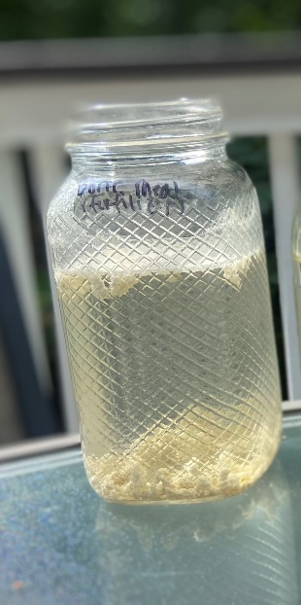
- Clear plastic cups and a sharpie
- Purchase plastic cups at Amazon: amzn.to/3ZjYCgZ
- Ticket out the Door
Prior to Lesson Day:
- Make contaminated water in a clear jar—add fertilizer
- Label each of the jars with the water that is in them.
Cover up the labels with a piece of paper and tape.
- Pre-label the plastic cups. Students will be divided into
groups and each group will receive a clear plastic cup
with one of each of the water samples, so label about
6 cups with each type of water (drinking water, pond water, name of local water source, the additional water)

Essential Question:
What is in the different types of water around us?
Introduction:
- Display the jars of water and have students guess where the water in each jar is from.
Tip: Set clear expectations. Before asking students to guess what’s in the jars, tell students to raise their hands before talking and wait to be called on.

Tip: Create an incentive. If you plan on having volunteers later in the lesson, let the students know now that students who are following your directions, being respectful of each other and you, raising their hands and not calling out, etc. may be able to be volunteers and help you.

- Once students have guessed, show labels for the jars.
Tip: Make it fun. Tell students to put their hands on their heads if they guessed the local water jar correctly, stick out their tongues if they guessed the drinking water correctly, stomp their feet if they guessed the pond water correctly, and twist from side to side if they guessed the 4th water correctly.

Tip: Joke around if the students are acting responsibly. If the students can handle it, feel free to make jokes about drinking some of the water. But be clear that it is a joke and students should never drink ground water!

Experiment:
Remember--Tip: Create and incentive. If you plan on having volunteers later in the lesson, let the students know now that students who are following your directions, being respectful of each other and you, raising their hands and not calling out, etc. may be able to be volunteers and help you.
Remember--Tip: Set clear expectations. Before asking students to guess what’s in the jars, tell students to raise their hands before talking and wait to be called on.

- Ask students about pollutants. Invite students to volunteer different pollutants they have learned about and discuss where they go.
  - Do they end up in the air and our lungs?
  - Do they end up on the ground, the bottom of our shoes, and then in our house?
  - Do they end up in our water?
- Explain that sometimes pollutants are good things that we add to the ground to help our plants grow, but when the plants don’t use all of them, they become waste in our soil, travel through the soil with water runoff, and then end up in lakes and ponds.
  - Have students predict what could happen to our water if too much extra fertilizer gets into it.
  - Explain what happens to our water when too much nitrogen and phosphorus gets into it.
- Tell students we will be testing the water from the jars to see what is in the water from our own environment.
- Divide students into small groups of 3-4. Each group receives:
Tip: Set expectations. Tell students that when the get their cups in front of them, do not keep their hands in their laps or off the table and not to move the cups around and spill the water. Tell them not to let the test strips touch the water yet.

  - a small, clear, labeled cup with each of the water samples (3-4)
  - a test strip for each water source (3-4)
  - a reference sheet
  - a paper plate or paper towels to place test strips on
Tip: Reinforce positive behavior. Ask students who have been following the classroom rules, raising their hands, being respectful of you and each other, etc. to be your helpers. They can distribute the cups, test strips, comparison guides, and paper plates/paper towels.

- Model how put the test strip in one of the cups of water for 2 seconds and then rest it on the paper towel. They must compare the colors immediately with the reference sheet (all parameters except for Nitrate and Nitrite can be read within 15 seconds. Nitrate and Nitrite can be read at 60 seconds). LABEL the paper plate or paper towel with which water source you used.
Tip: Assign roles. Assign roles or have students choose roles for their groups.
-Water Test Strip Dipper (dips the test strips.
-Label Maker (labels the paper plate/paper towel for each test strip)
-Reference Guide (manages the reference guide and holds it up to the test strips
-Manager (makes sure each student has the supplies they need for each step

- Have small groups test all of their water samples and label the paper towel/paper plate with the sample and test strip.
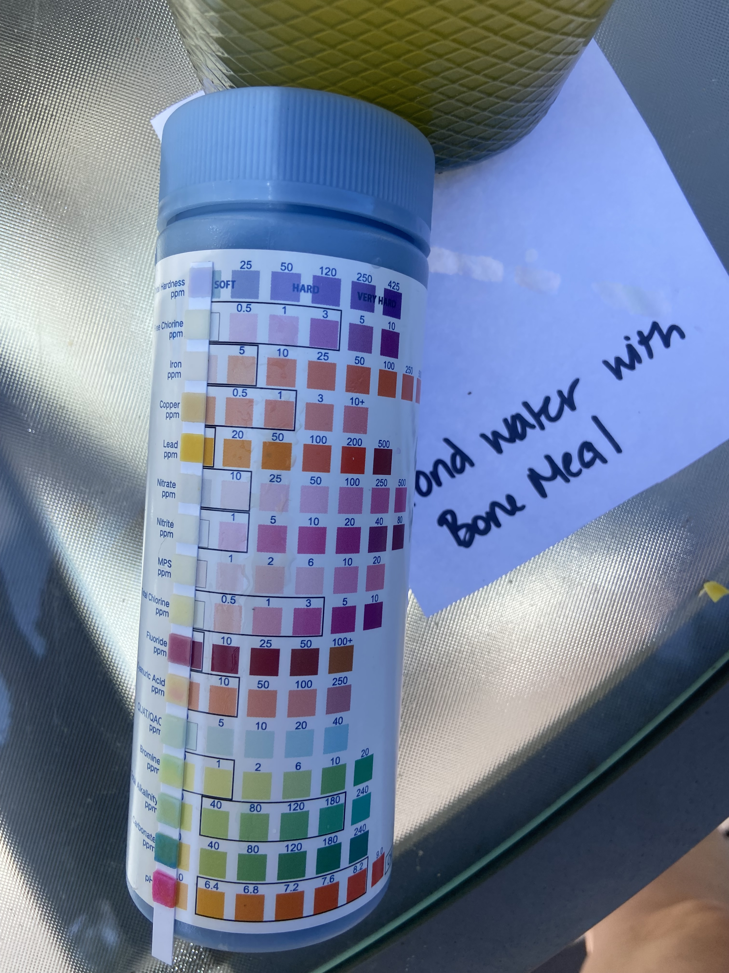

Tip: Be a time keeper. Give the students a 5 minute warning and then a 1 minutes warning. If the students are very engaged, they will lose track of time and not be ready to end their experiment when the time is up.

Discussion:
- Discuss your results. Have students share their results. Answer any questions about what is in their water.
  - Which is the safest to drink and why?
  - Which has the most contaminants?
  - Which were you surprised the most by?
  - Which has the most XXX
- Explain the roles Nitrite and Nitrates, as well as phosphorous in the water and how they impact our environment. Explain how fertilizer affects these levels.
- Did you know…Below is list provided in the Liberty Gold Standard Water Testing Kit. Share information about any parameters the students found out of the range or that they are curious about:
  - Lead: Lead can enter drinking water when your plumbing that contains lead corrodes. Corrosion of pipes can be caused by acid water (low pH). Side effects include damage to the nervous system, infertility, and decreased kidney function.
  - Iron: Iron is naturally occurring minerals that can enter your well water through surrounding soil, It does not pose a threat to your health, but can cause various complications with your appliances.
  - Free Chlorine: Most sterilized drinking water contains chlorine in the range of 0.2 -1 mg/L. Chlorine levels in drinking water can be up to 4 mg/L.
  - Nitrite: Nitrites comes from fertilizers through the runoff of water and sewage deposits. They can stimulate the growth of harmful bacterias.
  - pH: Water with a pH lower than 7 is considered acidic, and water with a pH above 8.5 is considered basic. A pH of 7 is considered pure, and a range of 6.5 to 8.5 is recommended.
  - Hardness: Hardness is the amount of dissolved calcium and magnesium. Soft water can cause corrosion of your plumbing and appliances. Hard water can cause residue buildup and difficulties using soap.
  - MPS (monopersulfate): Monopersulfate (monopersulfate or MPS) is a white, granular, free-flowing peroxygen that provides powerful non-chlorine oxidation for a wide variety of uses. It is the active ingredient in most nonchlorine oxidizers used for pool and spa/hot tub oxidation.
  - Cyanuric Acid: Cyanuric Acid is an organic disinfectant; it will accumulate continuously in the process of disinfection of drinking water. Too little will be decomposed by sunlight, and too much will easily affect the disinfection effect.
  - QUAT/QAC: Quaternary Ammonium Compounds (QACs) are a type of chemical that is used to kill bacteria, viruses, and mold. They are often found in disinfectants and in cleaning products.
  - Fluoride: Fluoride is a natural compound found in many rocks and is added to public water sources to prevent cavities. Groundwater can contain high levels of fluoride which can cause dental fluorosis and thyroid problems.
  - Copper: Copper can enter your drinking water through corrosion of pipes or direct contamination. High levels can cause nausea, vomiting, and diarrhea.
  - Total Chlorine: Chlorine is added to drinking water to kill disease causing pathogens. Total chlorine = Free Chlorine + Used chlorine (Chloramines) in your water. Nausea, diarrhea, and vomiting are common side of effects of ingesting too much chlorine.
  - Nitrate: Nitrate is one of the most common groundwater contaminants in drinking water. It most commonly comes from fertilizer runoff. Excess amounts can cause blue baby disease – a lack of oxygen to the brain.
  - Bromine: The bromine test is used to determine whether or not a carbon-carbon bond in unsaturated, such as in the case of an alkene or an alkyne.
  - Alkalinity: Alkalinity is the level of dissolved minerals in your water that helps neutralize acidity. Water with low levels of alkalinity are more likely to be corrosive, and high levels can cause scaling.
  - Carbonate: Carbonate hardness is a measure of carbonates and bicarbonates dissolved in water. It refers to the “buffering” ability of the water, which is how the water maintains a stable environment for aquatic life.
Ticket Out the Door:
- Have students and teachers complete the ticket out the door, located on the next page of this document.
Tip: The ticket out the door can either be printed in advance for students and teachers to write on, or you can write the questions on a white board and have students and teachers answer on a piece of notebook paper.

Further Investigations:
- With the teacher, students can engineer solutions to keep excess nitrates out of ground water. Grow algae in water.
- Are there ways to get rid of the algae after it begins to grow? How can we prevent nitrates and phosphates from entering our ground water?
- Investigate what happens when we have too many nitrates and phosphates in our water. See Algae and Pollution Experiment.

Ticket Out the Door
3. List 3 things you heard or saw today that were new.
____________________________________________________________________________________________
____________________________________________________________________________________________
____________________________________________________________________________________________
2. List 2 things that you are wondering about after seeing this experiment.
____________________________________________________________________________________________
____________________________________________________________________________________________
1. What is in the different types of water around us?____________________________________________
____________________________________________________________________________________________

Ticket Out the Door
3. List 3 things you heard or saw today that were new.
____________________________________________________________________________________________
____________________________________________________________________________________________
____________________________________________________________________________________________
2. List 2 things that you are wondering about after seeing this experiment.
____________________________________________________________________________________________
____________________________________________________________________________________________
1. What is in the different types of water around us?____________________________________________
____________________________________________________________________________________________
National Science Standards that compliment this lesson:
K-ESS3-1. Use a model to represent the relationship between the needs of different plants and animals (including humans) and the places they live.
- ESS3.A: Natural Resources: Living things need water, air, and resources from the land, and they live in places that have the things they need. Humans use natural resources for everything they do.
1-LS1-1. Use materials to design a solution to a human problem by mimicking how plants and/or animals use their external parts to help them survive, grow, and meet their needs
- LS1.A: Structure and Function All organisms have external parts. Different animals use their body parts in different ways to see, hear, grasp objects, protect themselves, move from place to place, and seek, find, and take in food, water and air. Plants also have different parts (roots, stems, leaves, flowers, fruits) that help them survive and grow.
- LS1.D: Information Processing: Animals have body parts that capture and convey different kinds of information needed for growth and survival. Animals respond to these inputs with behaviors that help them survive. Plants also respond to some external inputs.
2-LS4.1. Make observations of plants and animals to compare the diversity of life in different habitats.
- LS4-D: Biodiversity and Humans: There are many different kinds of living things in any area, and they exist in different places on land and in water.
3-5-ETS1-1. Define a simple design problem reflecting a need or a want that includes specified criteria for success and constraints on materials, time, or cost.
- ETS1.A: Defining and Delimiting Engineering Problems: Possible solutions to a problem are limited by available materials and resources (constraints). The success of a designed solution is determined by considering the desired features of a solution (criteria). Different proposals for solutions can be compared on the basis of how well each one meets the specified criteria for success or how well each takes the constraints into account.
3-LS1-1. Develop models to describe that organisms have unique and diverse life cycles but all have in common birth, growth, reproduction and death.
- LS1.B: Growth and Development of Organisms: Reproduction is essential to the continued existence of every kind of organism. Plants and animals have unique and diverse life cycles.
4-ESS3-2. Generate and compare multiple solutions to reduce the impacts of natural Earth processes on humans
- ESS3.B: Natural Hazards: A variety of hazards result from natural processes (e.g., earthquakes, tsunamis, volcanic eruptions). Humans cannot eliminate the hazards but can take steps to reduce their impacts.
- ETS1.B: Designing Solutions to Engineering Problems: Testing a solution involves investigating how well it performs under a range of likely conditions.
5-ESS3-1. Obtain and combine information about ways individual communities use science ideas to protect the Earth’s resources and environment.
- ESS3.C: Human Impacts on Earth Systems: Human activities in agriculture, industry, and everyday life have had major effects on the land, vegetation, streams, ocean, air, and even outer space. But individuals and communities are doing things to help protect Earth’s resources and environments.
MS-LS1-5. Construct a scientific explanation based on evidence for how environmental and genetic factors influence the growth of organisms
LS1.B: Growth and Development of Organisms. Genetic factors as well as local conditions affect the growth of the adult plant.
MS-LS2-1. Analyze and interpret data to provide evidence for the effects of resources availability on organisms and populations of organisms in an ecosystem.
- LS2.A: Interdependent Relationships in Ecosystems.
- Organisms, and populations of organisms, are dependent on their environmental interactions both with other living things and with nonliving factors.
- In any ecosystem, organisms and populations with similar requirements for food, water, oxygen, or other resources may compete with each other for limited resources, access to which consequently constrains their growth and reproduction.
- Growth of organisms and population increases are limited by access to resources.
MS-LS2-2. Construct an explanation that predicts patterns of interactions among living organisms across multiple ecosystems.
- LS2.A: Interdependent Relationships in Ecosystems. Similarly, predatory interactions may reduce the number of organisms or eliminate whole populations of organisms. Mutually beneficial interactions, in contrast, may become so interdependent that each organism requires the other for survival. Although the species involved in these competitive, predatory, and mutually beneficial interactions vary across ecosystems, the patterns or interactions of organisms with their environments, both living and nonliving, are shared.
MS-LS2-4. Construct an argument supported by empirical evidence that changes to physical or biological components of an ecosystem affect populations.
- LS2.C: Ecosystem Dynamics, Functioning, and Resilience. Ecosystems are dynamic in nature; their characteristics can vary over time. Disruptions to any physical or biological component of an ecosystem can lead to shifts in all its populations.
MS-ESS3-2. Analyze and interpret data on natural hazards to forecast future catastrophic events and inform the development of technologies to mitigate their effects.
- ESS3.B: Natural Hazards. Mapping the history of natural hazards in a region, combined with an understanding of related geologic forces can help forecast the locations and likelihoods of future events.
MS-ESS3-3. Apply scientific principles to design a method for monitoring and minimizing a human impact on the environment.
- ESS3.C: Human Impacts on Earth Systems.
- Human activities have significantly altered the biosphere, sometimes damaging or destroying natural habitats and causing the extinction of other species. But changes to Earth’s environments can have different impacts (negative and positive) for different living things.
- Typically, as human populations and per-capita consumption of natural resources increase, so do the negative impacts on Earth unless the activities and technologies involved are engineered otherwise.
MS-ESS3-5. Ask questions to clarify evidence of the factors that have caused the rise in global temperatures over the past century.
- ESS3.D: Global Climate Change. Human activities, such as the release of greenhouse gases from burning fossil fuels, are major factos in the current rise in Earth’s mean surface temperature (global warming). Reducing the level of climate change and reducing human vulnerability to whatever climate changes do occur depend on the understanding of climate science, engineering capabilities, and other kinds of knowledge, such as understanding of human behavior and on applying that knowledge wisely in decisions and activities.
MTS-ETS1-3. Analyze data from tests to determine similarities and differences among several design solutions to identify the best characteristics of each that can be combined into a new solution to better meet the criteria for success.
- ETS1.B: Developing Possible Solutions.
- There are systemic processes for evaluating solutions with respect ot how well they meet the criteria and constraints of a problem.
- Sometimes parts of different solutions can be combined to create a solution that is better than any of its predecessors.
- ETS1.C: Optimizing the Design Solution. Although one design may not perform the best across all tests, identifying the characteristics of the design that performed the best in each test can provide useful information for the redesign process—that is, some of those characteristics may be incorporated into the new design.

