What (and How) Do Plants Eat?
A module for engaging with K-12 students in their classroom on behalf of CASFER
This module can be adjusted to the grade level of the audience.
Purpose:
- Teach students some of the basic differences between plants and animals, including what they eat and how they consume nutrients.
- Demonstrate how plants take-up fertilizer from the soil along with water by capillary action.
- Challenge and inspire them to do a scientific experiment following the scientific method.
- Explain how fertilizer helps plants ONLY at certain times in the plant’s life and most of the fertilizer applied to the plant is not used and washed away in runoff.
- Do new seeks need fertilizer (no, it actually can hurt them).
- Explain the negative effects on the environment of fertilizer runoff.
- Explain the nitrogen circular economy.
Materials:
- Several celery stalks with some soaked for 24 hr in water with food coloring.
- Bag of dry beans from supermarket, two clear starter cups.
- Small envelope of Miracle Grow fertilizer for each student.
Demonstration and Script:
Step 1: Explain how plants take up water and nutrients by using celery. Examine the blue coloring of the xylem tubes in the celery pre-soaked in blue water compared to regular celery. The xylems are stained blue and the celery leaves are tinted blue. Water goes up the xylem by capillary action and evaporates out the leaves. The blue dye is left behind in the xylem and leaves. This is very different from how animals take in water (by mouth and water flows down from the head to the body).
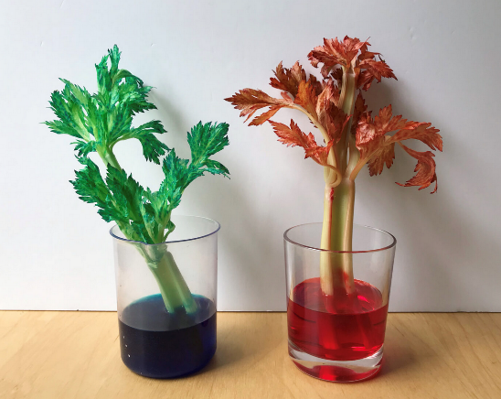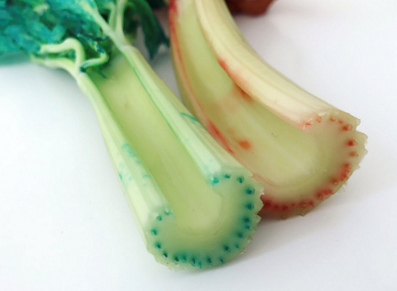
Optional Step 1: Demonstrate capillary action by using strips of paper towels and water based crayon markers. Color the ends of the paper towels and align them in a plate, as shown below. Add water and watch the water dilute the colors along the line of capillary action. You can also get creative and mix colors along the strip for more of an artistic effect.
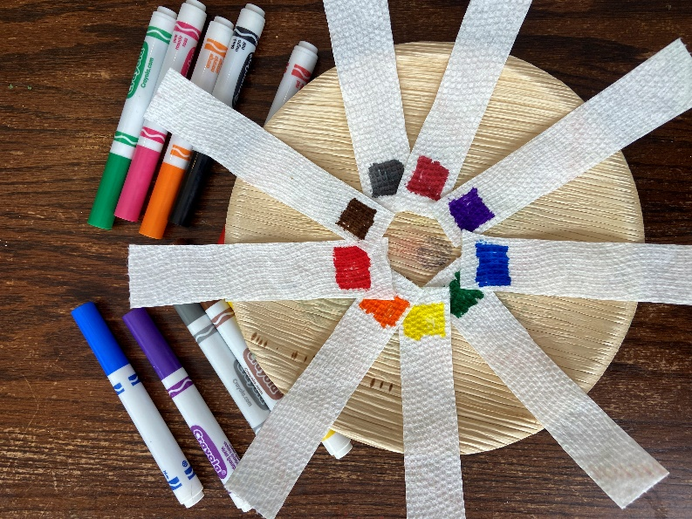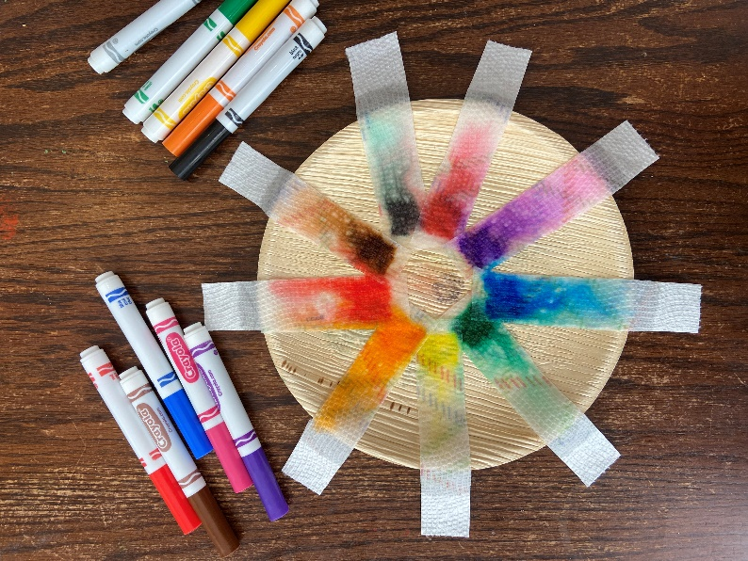

Step 2: What do plants eat (compared to what animals eat)? Plants (with leaves) need only water, nutrients (nitrogen, phosphorous and potassium); sunlight does the rest. This is very different from animals which need the four basic food groups. Nitrogen, potassium and phosphorous – kind of like vitamins to them. Show the bottle of Miracle Grow fertilizer and explain that it contains nitrogen, phosphorous and potassium.
Step 3: Give each student a small packet of beans, two clear cups, and small envelope of Miracle Grow. Ask them to wrap the beans in paper towel (two sets) and put the paper towel with beans in clear plastic cup. The paper towel should be on top of the water, kind of floating. Add some Miracle Grow into one of the cups. Label the cup with fertilizer. The beans will grow visitable roots in a couple days. Did the fertilizer help the beans to grow faster and bigger roots? [Answer: NO.] In fact, fertilizer hurts germination of seeds because it pulls water from the seed due to osmotic pressure of the salt water. Fertilizer is wasted and plant is hurt at germination.] You can do this experiment ahead of time and ask students to guess which one has fertilizer and which does not. It is a surprise to see that fertilizer hurts germination of the beans.
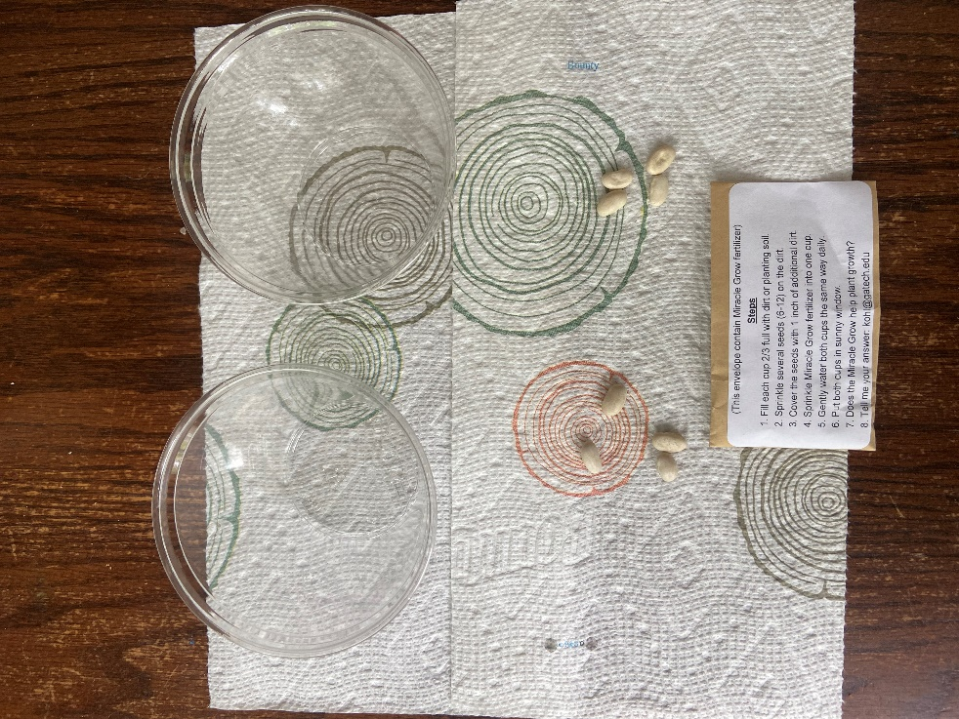

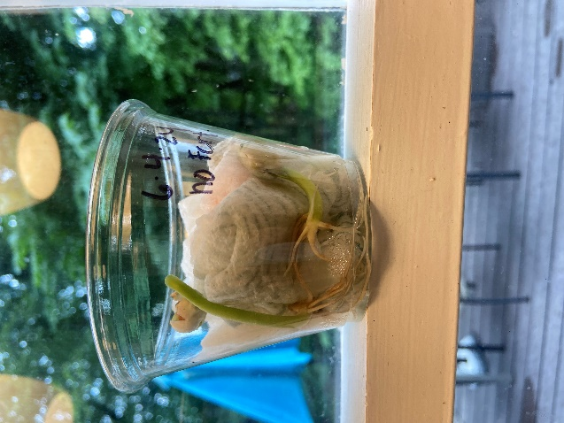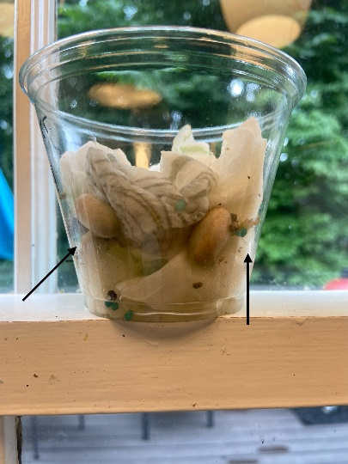
7 days: no fertilizer 7 days with fertilizer

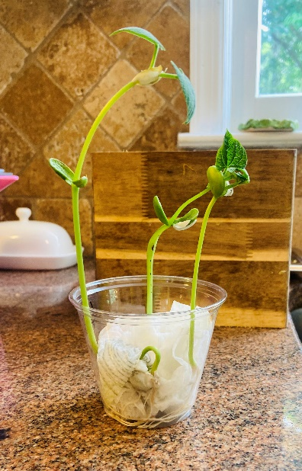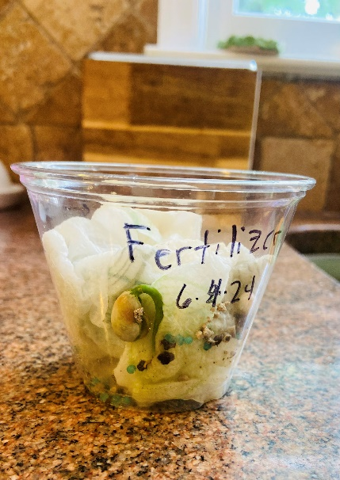
9 days: no fertilizer 9 days with fertilizer
Step 4: Sprouted beans can be replanted. Add fertilizer to some replanted beans. Fertilizer will help growth when leaves are present and sunlight stimulates growth.
Step 5: Send me an email and tell me what you observed. Were you able to keep the plants alive? Did the Miracle Grow help? Do you think all the Miracle Grow made it into the plants or did some get dissolved into the soil to be washed away?
Step 6: You can do other experiments with the growing plants. Turn the growing plants away from the sun and observe how the plant bends toward the sun by the next day. You can put a soft cover over some of the plants so they don’t get sunshine – what happens to it?

Ticket Out the Door
3. List 3 things you heard or saw today that were new.
____________________________________________________________________________________________
____________________________________________________________________________________________
____________________________________________________________________________________________
2. List 2 things that you are wondering about after seeing this experiment.
____________________________________________________________________________________________
____________________________________________________________________________________________
1. What happens to water in the soil and where do pollutants in the soil go? ______________________
____________________________________________________________________________________________

Ticket Out the Door
3. List 3 things you heard or saw today that were new.
____________________________________________________________________________________________
____________________________________________________________________________________________
____________________________________________________________________________________________
2. List 2 things that you are wondering about after seeing this experiment.
____________________________________________________________________________________________
____________________________________________________________________________________________
1. What happens to water in the soil and where do pollutants in the soil go? ______________________
____________________________________________________________________________________________

